RESUME

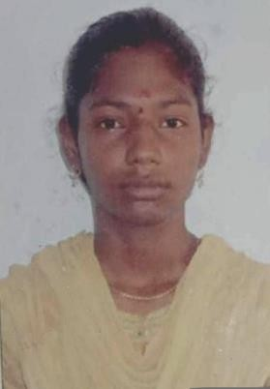

S . Gayathri ,

1/93 North street, P.Kaduvetti Paapakudi (po},

Udayarpalayam (TK).

Ariyalur DT.

Mobile :6385443792

Email [id : lovelygayu3107@gmail.com](mailto:id%20:%20%20%20lovelygayu3107@gmail.com)

# CAREER OBJECTIVE:

Seeking a challenging carrier in where I can design skills and academic knowledge will add value towards organization and personal growth.

# EDUCATIONAL QUALIFICATION:

|  |  |  |  |
| --- | --- | --- | --- |
| **Qualification** | **Institution** | **percentage** | **Year of passing** |
| Bsc Mathematics | Government arts college (Autonomous)  kombakonam ,  Thanjavur District. | **85%** | 2021 |
| **HSC** | Chandra Higher secondary school, Sethiyathopu | **78.33%** | **2017-2018** |
| SSLC | St.anthony's Higher  Secondary School,  Aranthangi. | 92.6**%** | 2015_2016 |

PERSONAL STRENGTH

* Confident and proactive
* Team player
* Friendly

# COMPUTER QUALIFICATION

* Basic Computer knowledge
* MS- Office

# PERSONAL DETAILS:

Name **: S.GAYATHRI**

Date of birth **:** 07.02.2002

Father Name : SELVAKUMAR

Gender : Female

Nationality : Indian

Religion : Hindu

Marital Status **:** Unmarried

Languages known **:** Tamil & English

# DECLARATION

I hereby declare that above mentioned information is true to best of my knowledge and I bear the responsibility for the above particulars.

Yours faithfully,

( **S.GAYATHRI**)

